# CS 255 System Design Document Template

## UML Diagrams

### UML Use Case Diagram

### UML Activity Diagrams

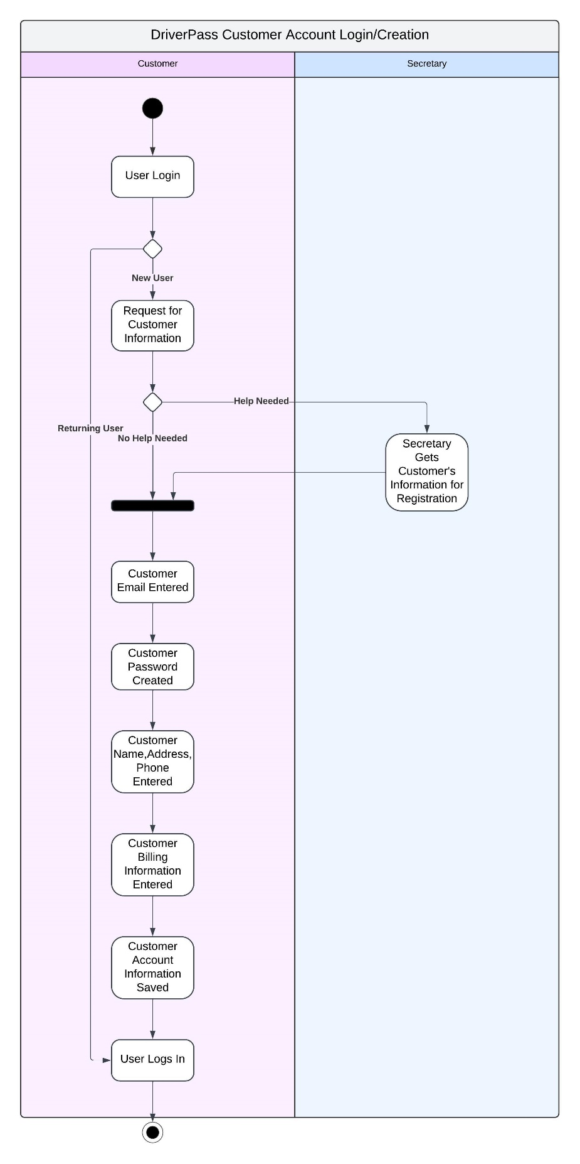

DriverPass Driving Lesson Reservations


### UML Sequence Diagram

### UML Class Diagram

## Technical Requirements

* Development:
  + Computers with broadband access that support development in JavaScript
    - Laptops
    - Desktops
  + JavaScript development software: VS Code is currently the most popular and is widely supported
* Cloud servers that support applications in JavaScript: programming and running
  + Supports most modern web browsers which will allow the client devices to be on most any operating system
* End User devices that support a modern browser: laptop, desktop, cell phone, tablet
  + Chrome
  + Firefox
  + Microsoft Edge
  + Safari
  + Opera
* Internet access throughout the entire development and use after
  + Broadband: hardwired or Wi-Fi
  + Cell service for mobile devices: at least 4G but 5G preferred